E-Enrollment User Guide
Version 1.0
http://e.fbr.gov.pk

Prepared by:
Registration Automation

Table of Contents
Important URLs and Numbers 4
1. What is e-Enrollment 5
2. Pre-Requisites 5
3. Enrollment Process 6
3.1 Swift Enrollment Steps for Salaried Individual 6
3.2 eFbr Enrollment for Business Individual, Aop And Company 10
4. How can you check your Enrollment Status? 14

List of Figures
Figure 1: URL enrollment 6
Figure 2: Swift enrollment 6
Figure 3: Basic information 7
Figure 4: Enrollment Application form 8
Figure 5: Verify button 8
Figure 6: Un-verify button 9
Figure 7: Submit button 9
Figure 8: Submitted Application 9
Figure 9: Activate Swift Enrollment 10
Figure 10: E-enrollment 10
Figure 11: E-enrollment Request 10
Figure 12: Screen for business individual 11
Figure 13: Screen for AOP 11
Figure 14: Screen for Company 11
Figure 15: e-enrollment Application form 12
Figure 16: Error message 12
Figure 17: Activation Code for AOP Company 13
Figure 18: Check status of enrollment 14

Important URLs and Numbers

Sr. | URL or Numbers | Purpose of URL or Numbers
 | http://e.fbr.gov.pk | To access the Official website to put request for Registration, e-Enrollment, file Returns(IT,ST)
 | http://regsys.fbr.gov.pk/enrollment/v.aspx | Enter Pass code (Received at Mobile No) and Activation code (Received at email Id) using the URL to activate Swift Enrollment. After the activation an email will be received by applicant on given email id containing “User_ID” and “Password” which can be used to login to the eFBR website.
 | http://regsys.fbr.gov.pk/v.aspx | Enter activation code (Recived at email Id) and email id to activate eFBR enrollment which is for Salaried Individual, AOP and Company.
 | http://www.fbr.gov.pk | Official website of FBR
 | https://e.fbr.gov.pk/Enrollment/ApplicationStatus.aspx | Check enrollment Application Status
 | Help line 24 hours | 051-111-772-772

What is e-Enrollment
E-Enrollment is a formal process which a Registered Taxpayer can get through to enroll himself at http://e.fbr.gov.pk to get “User ID” and “Password” . This “User ID” and “Password” helps the Taxpayer to log in to the system to manage his tax related activities.
There are two e-Enrollment modes for following taxpayer types:-
- Salaried Individual should e-Enrolled using “Swift Enrollment Process”.
This is a quick process in which user gets enrolled quickly and gets user_id and password without going into form approval process by TFC.
- Business Individual, AOP and Company should e-Enrolled using “eFBR Enrollment Process”.
This is a formal approval process to get enrolled.

Pre-Requisites
Following are the pre-requisites to get e-Enrolled:
- Taxpayer must be Registered and have active NTN.
- Taxpayer must give valid email ID through which he can receive intimations.
- Taxpayer must give valid mobile numbers to get SMS intimations.

Enrollment Process
There are two types of Enrollment processes.
- Swift Enrollment (For Salaried Individual)
- E Fbr Enrollment (For Business Individual, AOP And Company)

Swift Enrollment Steps for Salaried Individual
Salaried person can follow these steps to get e-enrolled.
- Go to the URL: http://e.fbr.gov.pk/
Figure 1: URL enrollment
- Click on “Swift enrollment for salaried individual” link under the menu e-Enrollment tab.
Figure 2: Swift enrollment

When user will click on the Swift Enrollment for Salaried Individual menu, the following screen will be displayed as figure 3:

- Enter Basic Particulars on web page (i.e., NTN, CNIC and Image-Characters) and press "Next" button
Figure 3: Basic information
- E-Enrollment Application Form will be displayed showing your particulars available in the system. Complete the missing information of your profile carefully in e-Enrollment Application Form.
- Click "Prepare" Button after completing the missing information.

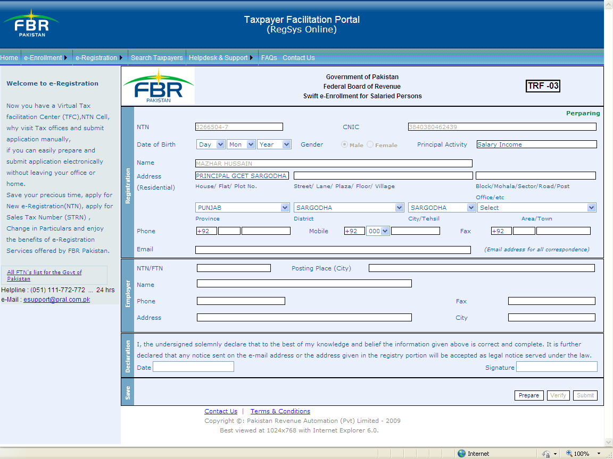
The status of the application will be displayed here
Figure 4: Enrollment Application form
- The system will the message “Enrollment Data has been successfully saved”
- Click "Verify" Button to finally confirm the changes.
Figure 5: Verify button
- If you want to make further changes after "Verification" process is completed, you have to un-verify your form by clicking "Un-Verify" button.
Figure 6: Un-verify button
- Click "Submit" Button to submit your e-Enrollment application.
Figure 7: Submit button
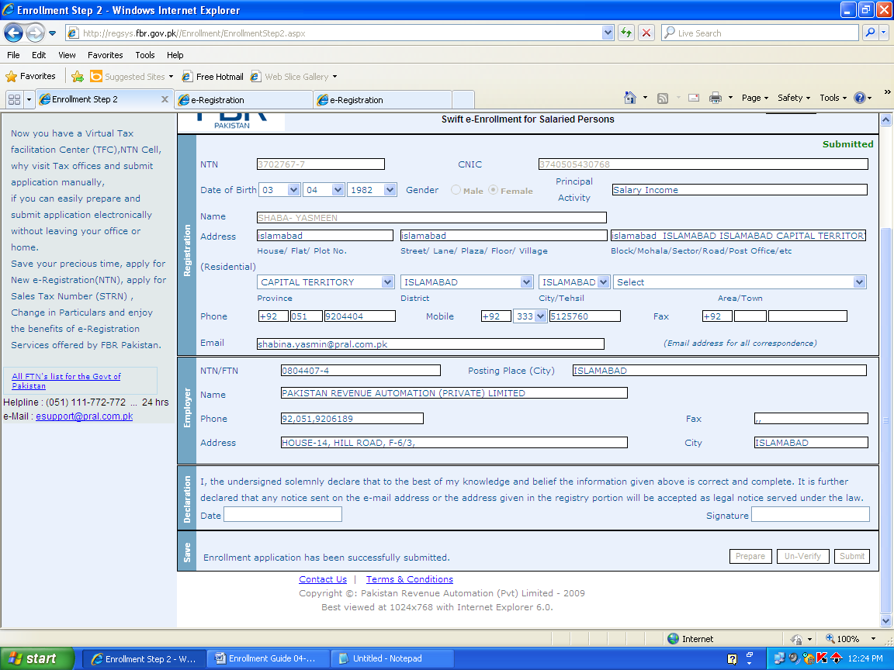
Figure 8: Submitted Application
- You will receive an SMS on your Cell Phone showing the "Activation Code" and on email you will receive “Pass Code”.
- You will receive your User-ID & Password by email in your email address.
- Please verify the application by entering the Activation code and pass code on the URL http://regsys.fbr.gov.pk/enrollment/v.aspx as shown in figure 9. After successful activation you will receive the “User_Id” and “Password” at the email address.
- After receiving the “User ID” and “Password” at your given email ID, you will be able to log in to the system using URL http://e.fbr.gov.pk
Figure 9: Activate Swift Enrollment

eFbr Enrollment for Business Individual, Aop And Company
AOP, Company and business individual can use this module for E-enrollment.
- Click on “eFBR enrollment” under e-Enrollment link from the main menu.
Figure 10: E-enrollment
- Select his taxpayer type and then enter the image.
Figure 11: E-enrollment Request

The following screens will appear depending upon the selected taxpayer type
- For individual
Figure 12: Screen for business individual
- For AOP
Figure 13: Screen for AOP
- For Company
Figure 14: Screen for Company

- The user will fill the following fields:
  - Phone
  - Email
  - Mobile
  - Rest of the fields will be fetched by the system.
Note: - The entered information must be matched with the information which was given at the time of NTN or STRN Registration.

Figure 15: e-enrollment Application form
- The user will see the following message if he has entered mismatched data than the data provided at the time of Registration.
Figure 16: Error message
- Activation code will be sent on e-mail.
- The user will enter the activation code (received via email) to confirm his application. Then click “Activate” button.
Figure 17: Activation Code for AOP Company
- User id and password will be emailed to taxpayer if enrollment will be approved after telephonic verification.
- Email intimation will be sent, if taxpayer enrollment application will be rejected by ETO.

Note: - If email or SMS is not received within one hour after submission the enrollment request, please call our Helpline on 051-111-772-772.

How can you check your Enrollment Status?
Follow the following quick steps to check the status of enrollment.
- Go to URL:https://e.fbr.gov.pk/enrollment/applicationstatus.aspx or follow the navigation enrollment=>Check Status of e-Enrollment Application
- Enter the NTN.
- Enter the image character.
- Click the “Submit” button.

Figure 18: Check status of enrollment

