Date of Publication: 17th July 2016
User Guide for Sales Tax Return
(Filing Annex-C, A & I)

Index
0
Logon to FBR Portal 2
Selection of Sales Tax Return (2016-17) 2
Access Annex-C (Sales) 3
Input Sale Invoice 4
Add Invoice in the “Annex-C” Grid. 5
Access Annex-A (Purchases) 7
Input Purchase Invoice 9
Add Invoice in the “Annex-A” Grid. 10
Load Multiple Purchase Invoices in “Annex-A” 10
Access Annex-I (Debit – Credit Note) 12
Prepare Credit Note (Seller) 13
Add Credit Note in “Annex-I” Grid. 15
Load Debit/Credit Notes in “Annex-I” 15
ST-Return Clause - 7a, 7b & 7c 17

Screen Reference | Steps | Action
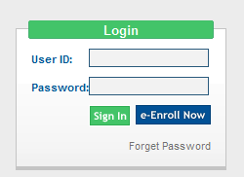 | - Click on the link below or type this link in your Internet browser address bar.  https://fbr.gov.pk/  - Login screen shall appear.  - Enter your registered User ID in the “User ID” field.  - Enter the password you received on your cell phone or email address in “Password” field.  - Click “Sign In” button.  - In case of incorrect User ID or Password, you shall receive error message “Invalid User name or Password”. | Logon to FBR Portal
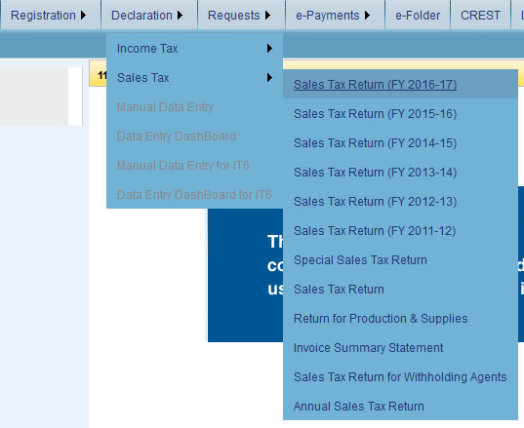  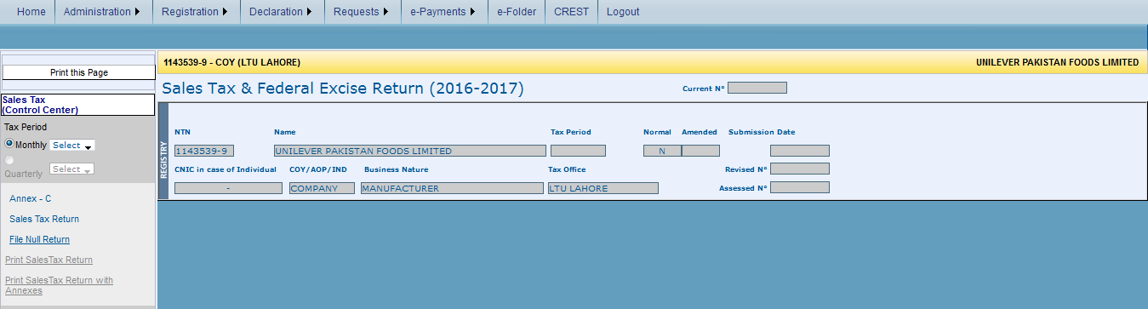 | - On successful login, following screen shall appear.  - Click “Declaration” link from the top menu.  - Select “Sales Tax” and from the sales tax menu click “Sales Tax Return (FY 2016-17)” option.  - Profile screen shall appears. | Selection of Sales Tax Return (2016-17)
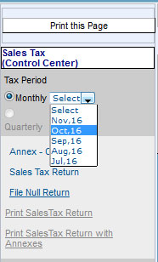  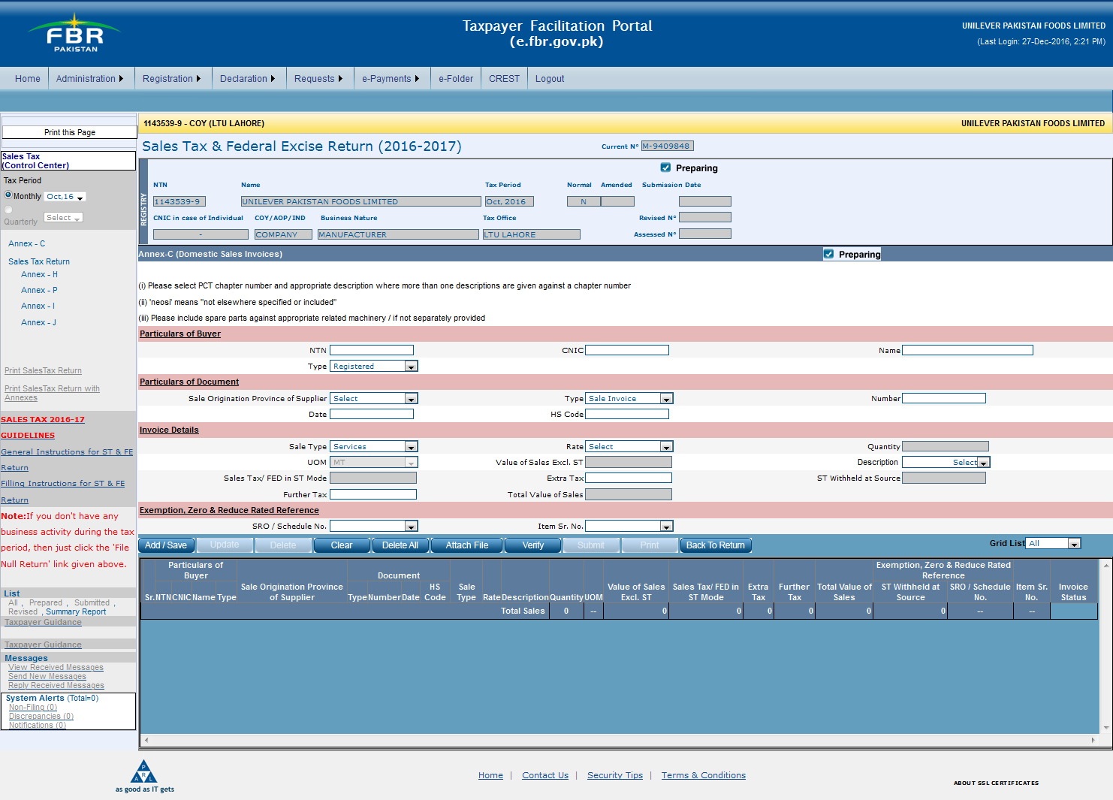 | - Select sales tax return “Month” from left column.  - Click “Annex-C” from left column.  - “Annex-C” screen appears.  - Read the instructions carefully under title “Annex-C (Domestic Sales Invoices)” section. | Access Annex-C (Sales)
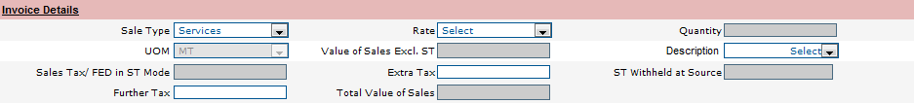 | - In the “Particulars of Buyer” section, enter information in all mandatory fields.  - In NTN field enter NTN number of buyer.  - In CNIC Field enter CNIC of buyer.  - In name field enter name of the buyer.  - Select the type of buyer from the options listed in “Type” list.  - In the “Particulars of Document” section, enter information in all mandatory fields.  - Select the “Sale Origination Province of Supplier” from the respective dropdown list.  - Select type of the document in “Type” dropdown list.  - Enter identification number of the document in “Number” field.  - Enter the date of the document created in the “Date” Field.  - Enter HS-Code of the product sold in the “HS-Code” field.  - Enter details of invoice in the “Invoice Details” Section.  - Select desired option from “Sale Type” dropdown list.  - Select the sales tax rate from the “Rate” dropdown list.  - Select description of purchaser in the “Description” dropdown list.  - Enter value of extra tax in the “Extra Tax” field.  - Enter value of further tax in the “Further Tax” field.  - Following fields will be automatically calculated and filled by the system.  - Quantity  - UOM  - Value of Sales Excl. ST  - Sales Tax/ FED in ST Mode  - ST Withheld at Source  - Total Value of Sales  - Enter references of exemption, Zero and reduced rate in the section named “Exemption, Zero and Reduced Rated References”.  - Select related SRO or Schedule No. from the “SRO/Schedule No.” dropdown list.  Select item’s serial number on which SRO or Schedule number applies from the “Item Sr. No.” dropdown list. | Input Sale Invoice
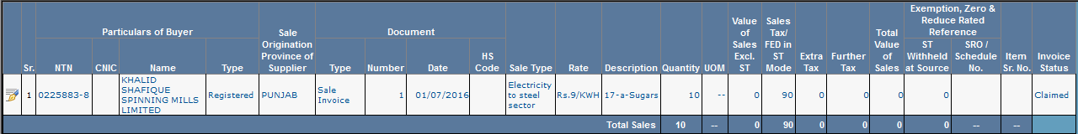  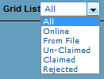 | - Click “Add & Save” button below in the menu bar as shown in the menu screen.  - The record will be inserted in the Annex-C grid as shown in the screen.  - Record can be edited by clicking “Edit” icon in the first column of the unclaimed record. All the values will be displayed in the fields above the grid and will be editable.  - After editing the record, click “Update” button in the menu to save updated record.  - Click “Edit” icon against the unclaimed record, “Delete” button will be enabled. Click “Delete” button in order to delete the record.  - Click “Clear” button to clear all the information from the fields in order to enter new information.  - In case there are more than one unclaimed records in the grid, “Delete All” button will be activated. Click “Delete All” button to delete all unclaimed records.  - In order to upload multiple invoices though an excel file. Click “Attach File” button. Following screen shall appear.  - Click “Download Sample File” link to download the excel template file in which data is required.  - Click “Browse” button to select excel file.  - Click “Import Data” button to start processing the excel file for extracting information into the system.  - All invoices will be imported and displayed in the grid as shown in the screen.  - Once all invoices are entered for the month and data is verified manually with the invoice books, click “Verify” button to verify all data.  - System will display all relevant invoices in the “Annex-A” of relevant Purchasers.  - Once the Purchaser has claimed an Invoice, the status of the invoice in “Annex-C” will be changed to “Claimed”, the invoice is locked and cannot be editable or delete able.  - The “Un-Verify” button will be active for the invoices which are not yet claimed by the purchaser and can be editable.  - Click “Un-Verify” to remove the invoice from the purchaser’s “Annex-A”.  - Click “Submit” button to submit the Annex-C.  - Click “Print” button to print the information of Annex-C.  - Click “Back to Return” button in order to switch to return screen.  - Click “Grid List” dropdown list to view grid as per selected option. | Add Invoice in the “Annex-C” Grid.
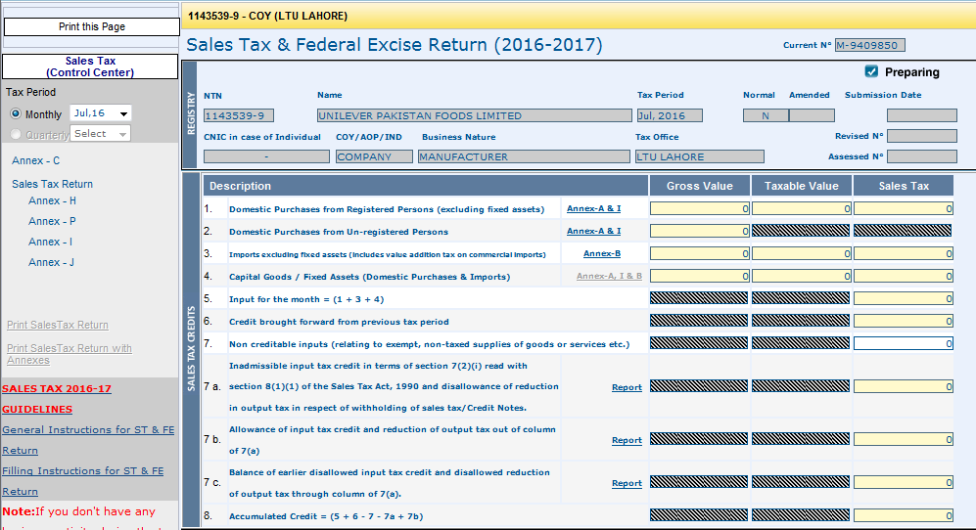  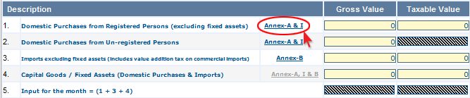  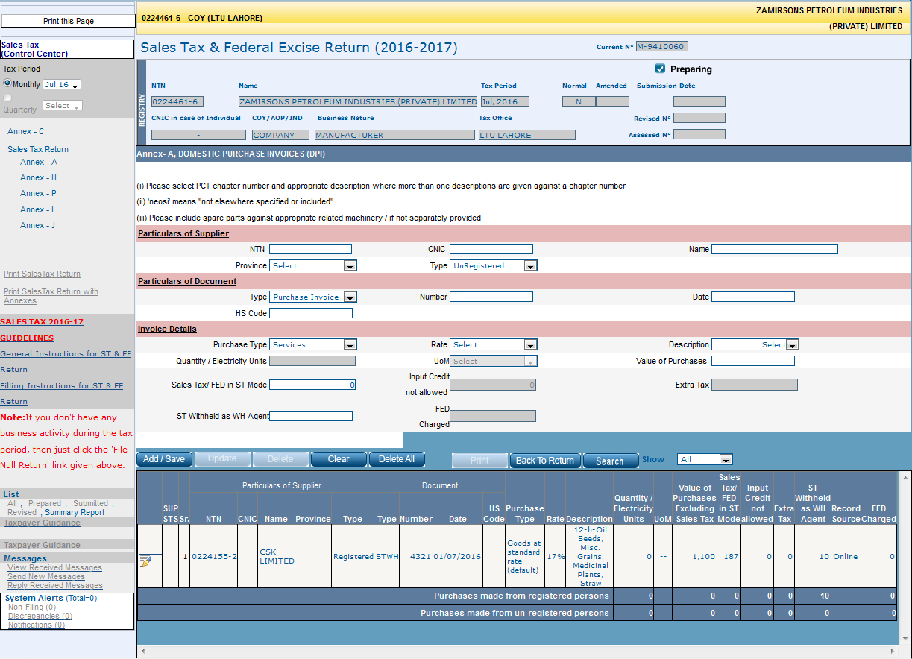 | - In order to access the “Annex-A”.  - Select sales tax return “Month” from left column.  - Click “Sales Tax Return” from left column. Following Screen shall appears.  - Click “Annex-A & I” from the grid, as mentioned in the screen.  - “Annex-A” screen shall appear.  - Read the instructions carefully under title “Annex-A (Domestic Purchase Invoices)” section.  Note:  - Manual invoice entry is eligible for all “Un-Registered Sellers”.  - For “Registered Seller” invoices, with invoice dates between 1st February and 30th July, 2016, can be entered manually against the monthly ST-Return from August 2016 to January 2017.  - ST-Return can only be valid for the 6-months old seller invoices. | Access Annex-A (Purchases)
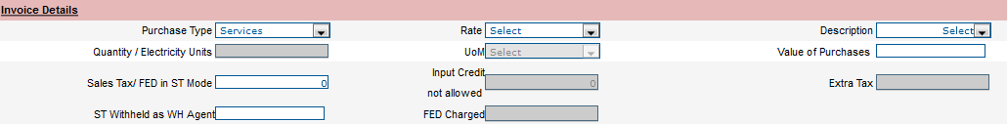 | - In the “Particulars of Supplier” section, enter information in all mandatory fields.  - In NTN field enter NTN number of seller.  - In CNIC Field enter CNIC of seller.  - In “Name” field enter name of the seller.  - Select the type of buyer from the options listed in “Type” list.  - In the “Particulars of Document” section, enter information in all mandatory fields.  - Select purchase type of the document in “Type” dropdown list.  - Enter identification number of the document in “Number” field.  - Enter the date of the document created in the “Date” Field.  - Enter HS-Code of the product sold in the “HS-Code” field.  - Enter details of invoice in the “Invoice Details” Section.  - Select desired option from “Purchase Type” dropdown list.  - Select the sales tax rate from the “Rate” dropdown list.  - Select description of Seller in the “Description” dropdown list.  - Enter value of purchases in the “Value of Purchases” field.  - Enter value of tax in the “Sales Tax/FED in ST Mode” field.  - Enter value of Sales Tax deducted as withholding agent in the “ST Withheld as WH Agent” field.  - Following fields will be automatically calculated and filled by the system.  - Quantity/Electricity Units  - UOM  - Input Credit Not Allowed  - Extra Tax  - FED Charged | Input Purchase Invoice
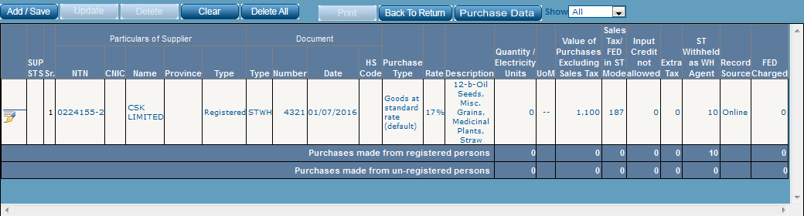  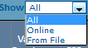 | - Click “Add & Save” button in the menu bar as shown in the Annex-A grid screen.  - The record will be inserted in the Annex-A grid as shown in the screen.  - Record can be edited by clicking “Edit” icon in the first column of the record. All the values will be displayed in the fields above the grid and will be editable.  - After editing the record, click “Update” button in the menu to save updated record.  - Click “Edit” icon against the record, “Delete” button will be enabled. Click “Delete” button in order to delete the record.  - Click “Clear” button to clear all the information from the fields in order to enter new information.  - In case there are more than one record in the grid, “Delete All” button will be activated. Click “Delete All” button to delete all records.  - Click “Print” button to print the information of Annex-A.  - Click “Back to Return” button in order to switch to ST-Return screen.  - Click “Show” dropdown list to view grid as per selected option. | Add Invoice in the “Annex-A” Grid.
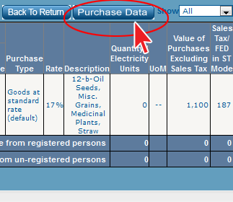  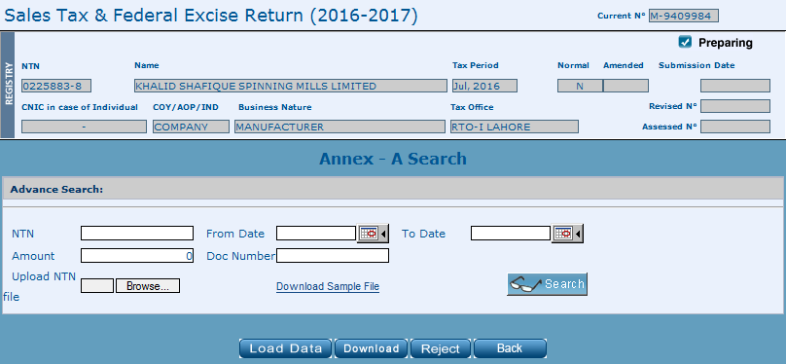  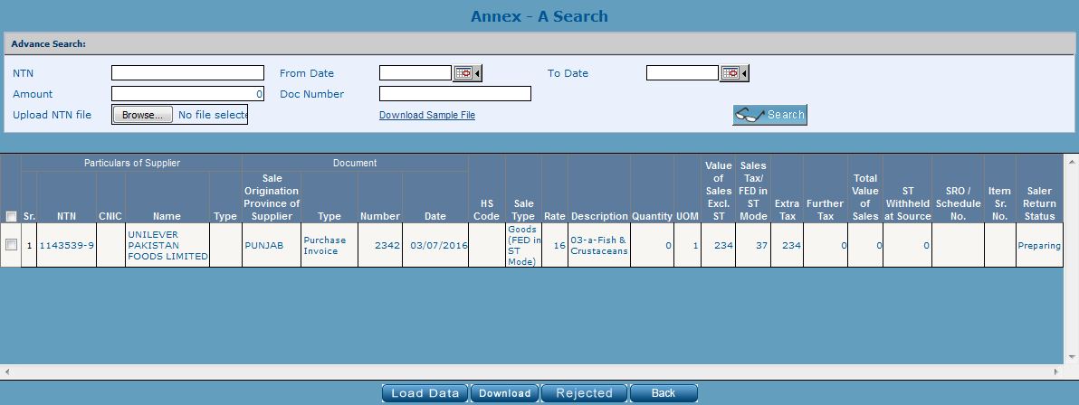 | - In order to import multiple invoices though an excel file. Click “Purchase Data” button.  - Following screen shall appear.  - In order to display all the invoices, click “Search” button.  - All invoices will be displayed in the grid.  - In order to search specific sellers invoices.  - Click “Download Sample File” link to download the excel template file in which data is required.  - Type sellers NTN numbers in the sample file as per template.  - Click “Browse” button to select excel file.  - Click “Load Data” button to start processing the excel file for extracting information into the system.  - All available invoices of the sellers against NTN numbers will be loaded in the search grid as shown in screen.  - Manually search invoice by typing related information in the “NTN”, “From Date”, “To Date”, “Amount” and “Doc Number” fields and press “Search” button.  - In case one or more record(s) is to be downloaded for verification, click the check boxes in the first column of the grid and click “Download” button.  - In case one or more record(s) is to be rejected, click the check boxes in the first column of the grid and click “Rejected” button.  - Click “Back” button to go back to ST-Return screen. | Load Multiple Purchase Invoices in “Annex-A”
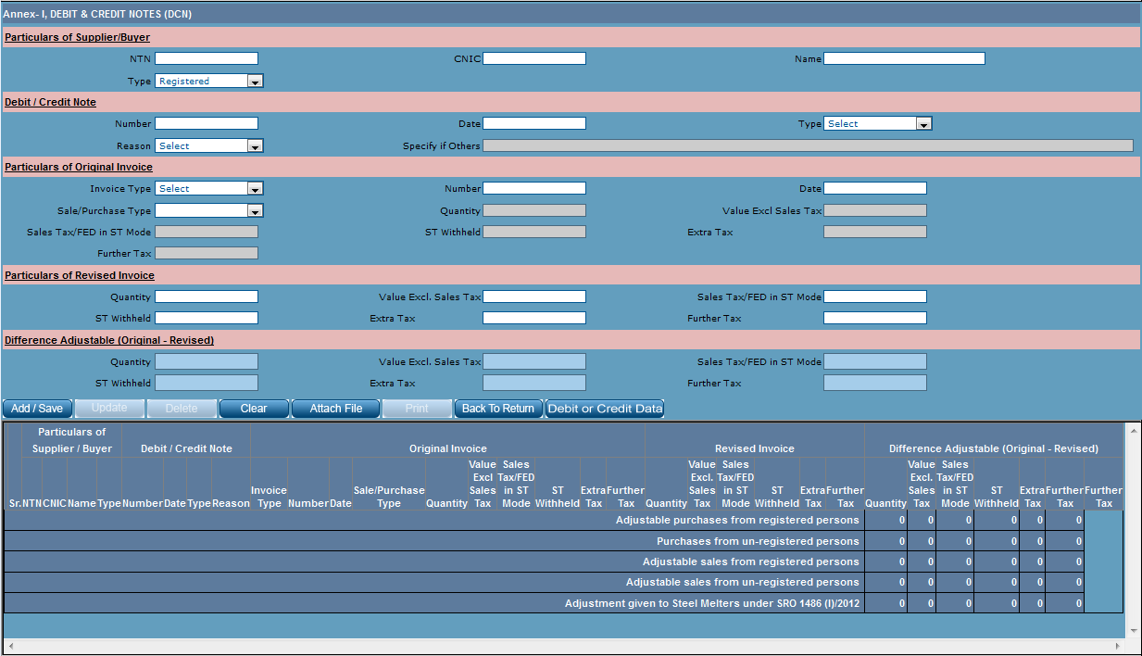 | - In order to access the “Annex-A”.  - Select sales tax return “Month” from left column.  - Click “Sales Tax Return” from left column. Following Screen shall appears.  - Select “Annex-I” from the left column as shown in the screen. | Access Annex-I (Debit – Credit Note)
 | - In the “Particulars of Supplier/Buyer” section, enter information in all mandatory fields.  - In NTN field enter NTN number of seller.  - In CNIC Field enter CNIC of seller.  - In “Name” field enter name of the seller.  - Select the type of supplier/buyer from the options listed in “Type” list.  - In the “Debit/Credit Note” section, enter information in all mandatory fields.  - Enter number of debit/credit note in “Number” field.  - Enter the date of the document created in the “Date” Field.  - Select Note type e.g. Debit or Credit Note, from the “Type” dropdown list.  - Select reason of creating Debit/Credit Note from the “Reason” drop down list.  - If the reason is not in the “Reason” list select “Others” options, the “Specify if Others” field will be enabled, Enter reason of creating Debit/Credit note in the “Specify if Others” filed.  - Enter details of original invoice in the “Particulars of Original Invoice” Section.  - Select desired option from “Invoice Type” dropdown list.  - Enter number of Original Invoice in “Number” field.  - Enter the date of the Invoice in the “Date” Field.  - Select the sale/purchase type from the “Sale/Purchase Type” dropdown list.  - Following fields will be automatically calculated and filled by the system.  - Quantity  - Value Excl Sales Tax  - Sales Tax/FED in ST Mode  - ST Withheld  - Extra Tax  - Further Tax  - Enter details of revised invoice in the “Particulars of Revised Invoice” Section.  - Enter revised quantity in “quantity” field.  - Enter the revised value of sales tax excluded in the “Value Excl Sales Tax” field.  - Enter the revised value of sales tax/FED in sales tax mode excluded in the “Sales Tax/FED in ST Mode” field.  - Enter value of sales tax withheld in “ST Withheld” filed.  - Enter value of extra tax in “Extra Tax” field.  - Enter value of further tax in “Further Tax” field.  - All the values will be automatically calculated by the system in “Difference Adjustable (Original-Revised)” Section.  - Following fields will be automatically calculated and filled by the system.  - Quantity  - Value Excl Sales Tax  - Sales Tax/FED in ST Mode  - ST Withheld  - Extra Tax  - Further Tax | Prepare Credit Note (Seller)
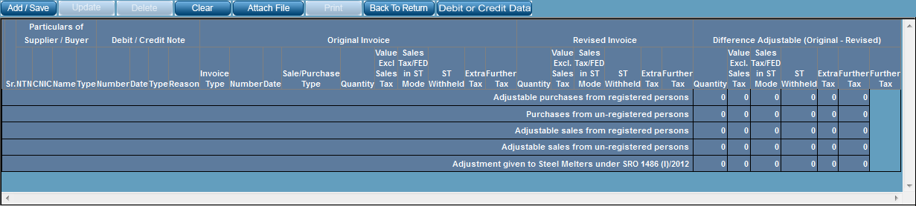 | - Click “Add & Save” button in the menu bar as shown in the Annex-I grid screen.  - The credit note will be inserted in the Annex-I grid as shown in the screen.  - Credit Note can be edited by clicking “Edit” icon in the first column of the record. All the values will be displayed in the fields above the grid and will be editable.  - After editing the record, click “Update” button in the menu to save updated record.  - Click “Edit” icon against the record, “Delete” button will be enabled. Click “Delete” button in order to delete the record.  - Click “Clear” button to clear all the information from the fields in order to enter new information.  - Click “Print” button to print the information of Annex-I.  - Click “Back to Return” button in order to switch to ST-Return screen.  - In order to upload multiple invoices though an excel file. Click “Attach File” button. Following screen shall appear.  - Click “Download Sample File” link to download the excel template file in which data is required.  - Click “Browse” button to select excel file.  - Click “Import Data” button to start processing the excel file for extracting information into the system.  - Click “Back to Return” button to go back to ST-Return screen.  - Click “Back to Annex-I” button to navigate back to Annex-I screen. | Add Credit Note in “Annex-I” Grid.
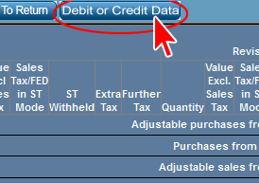  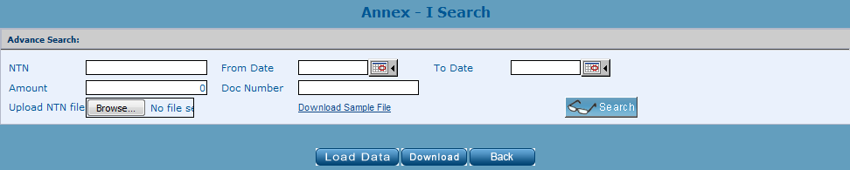 | - In order to import Debit/Credit Notes though an excel file. Click “Debit or Credit Data” button.  - Following screen shall appear.  - In order to display available Debit/Credit notes, click “Search” button.  - All related Debit/Credit notes will be displayed in the grid.  - In order to search Debit/Credit note by specific Seller/Buyer. Fill in one of the following search criteria.  - Type Seller/Buyer NTN in “NTN” field.  - Select dates of Debit/Credit notes in the “From Date” and “To Date” fields.  - Type amount of Debit/ Credit Note in “Amount” field.  - Type document number in the “Document Number” field.  - Click “Search” button, all the relevant records will be displayed in the grid below.  - Click “Download Sample File” link to download the excel template file in which data is required.  - Type sellers NTN numbers in the sample file as per template.  - Click “Browse” button to select excel file.  - Click “Load Data” button to start processing the excel file for extracting information into the system.  - All available invoices of the sellers against NTN numbers will be loaded in the search grid as shown in screen.  - In case one or more record(s) is to be downloaded for verification, click the check boxes in the first column of the grid and click “Download” button.  - In case one or more record(s) is to be rejected, click the check boxes in the first column of the grid and click “Rejected” button.  - Click “Back” button to go back to ST-Return screen. | Load Debit/Credit Notes in “Annex-I”
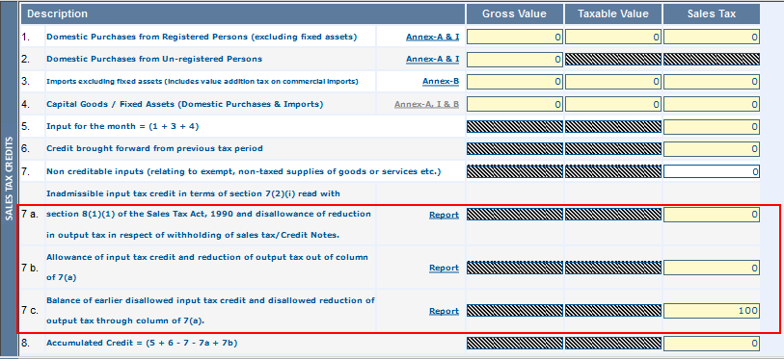  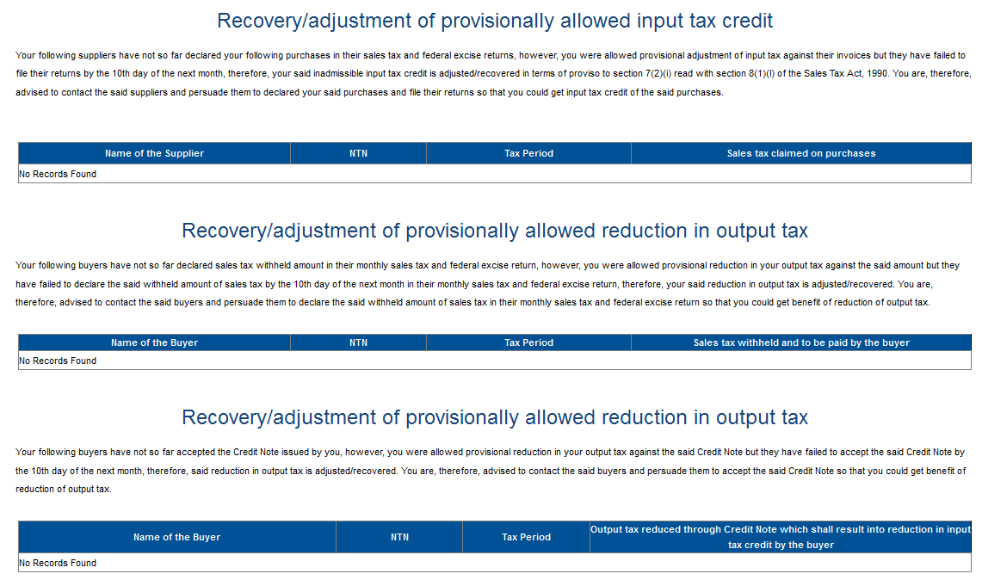 | Note: Impact on ST-Return  - In case Buyer/Supplier did not submitted the return of that time period, the un-paid tax will be displayed in the subsequent ST-Return of corresponding Buyer/Supplier in ST-Return Clause 7a.  - The corresponding Buyer/Supplier will not be able to submit ST-Return until they pay the tax displayed in ST-Return Clause 7a.  - In case corresponding Buyer/Supplier pays the outstanding tax displayed in ST-Return Clause 7a, the ST-Return can be filed and the paid tax will be displayed in the ST-Return Clause 7c.  - In case the non-compliant buyer/seller pays the outstanding tax in future, the amount will be credited to the corresponding Buyer/Seller and is deducted from Clause 7c and displayed in ST-Return Clause 7b.  - In order to view details of overdue tax and the non-compliant Buyers/Suppliers, click “Report” link against ST-Return clauses 7a,b & c.  - Following screen shall appear.  - The report displays following information:  - Name of Supplier/Buyer  - NTN  - Tax period  - Description of tax amount which shall be debited or credited. | ST-Return Clause - 7a, 7b & 7c

