GUIDELINES TO E-FILE
INCOME TAX RETURNS
2008

Table of Contents

Sr. | Topic | Page
1.0 | Basic Steps to e-File Annual Income Tax Return | 3
2.0 | Stepwise Income Tax Return e-Filing Guideline | 5
2.1 | Pre-requisites of e-Filing | 5
2.2 | How to open Annual Return of Income Tax | 5
2.3 | Sections of Income Tax Return Form | 6
2.3.1 | Registration Section | 6
2.3.2 | Share Holding/Ownership Section | 7
2.3.3 | Other Sections of the Return | 7
2.3.3.1 | Annexures | 7
2.3.3.2 | Audited Accounts Section (ONLY for IT-1 (Company)) | 9
2.3.3.3 | Payment/Refund Section | 10
3.0 | Buttons in the form | 10
3.1 | Save | 10
3.2 | Verify & Unverify | 11
3.3 | E-Payment & Enter CPR No | 11
3.4 | Submit | 11
3.5 | Revise | 12
3.6 | Print Return | 12
3.7 | Acknowledgment | 12
4.0 | Important Points to Note | 13

1.0 Basic Steps to e-file Annual Income Tax Return

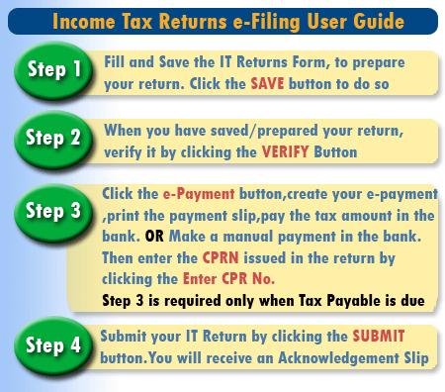

Summary

- Log into the website by entering the User ID & Password.
- For updating the Registration information click the link “Click Here to update”.
- If you are a Company or AOP, make sure to add your Directors/Share Holders in the Registration->Enrollment->Profile Management module.
- Fill the Return as per Instruction. Fill only the fields that apply to you.
- Bank fields are optional. These fields are only for Refundable Amount. If bank branch not is available, don’t fill the bank fields.
- Save the return.
- Then you can verify or unverify the return. If you unverified the Return then you have to save the return again.
- After verifying the return, if there is some amount against Net Tax Payable (Code:99991) ,create e-Payment by clicking the e-Payment button or make manual payment in the bank, against your Income Tax Return.
- Pay the tax amount due in the bank. You will be issued a CPR Number against the payment.
- In the main return form, click the “Enter CPR No.” button and enter the CPR No, along with the amount paid against the CPR No.
- Now submit the Return by clicking the “Submit” Button.
- Return can be revised by clicking the “Revise” Button.
- Then you can edit the return and then perform the same process to the revised return.

- Due Date for e-Filing of IT-1 (Company) is 31st October for companies whose year-ending date is 31-12-2007.
- Due Date for e-Filing of IT-1 (Company) is 31st December for companies whose year-ending date is 30-06-2008.
- Due Date for e-Filing of IT-2 (Individuals/AOP/Others) is 31st October.

2.0 Stepwise Income Tax Return e-Filing Guideline:-

2.1 Pre-requisites of e-Filing

Enrollment : The tax payer MUST BE ENROLLED on the eFBR Portal, in order to file an
Income Tax Return

2.2 How to open Annual Return of Income Tax:

2.2.1 After Login, click the Menu Item shown below.

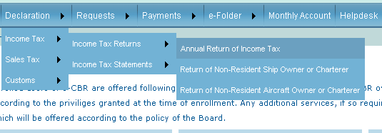

    - Selecting the Tax Payer / Return
a) In case of e-Intermediary Select the Client from the list of Taxpayers.

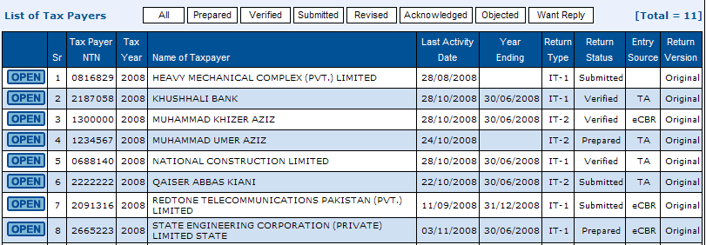

b) In case of Company or Individual/AOP select from the list of yearly Returns.

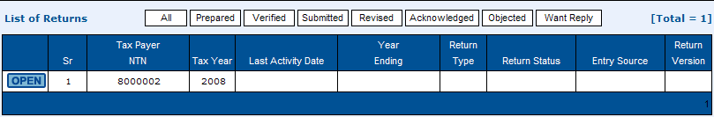

    - Select the Return type from Left Menu.

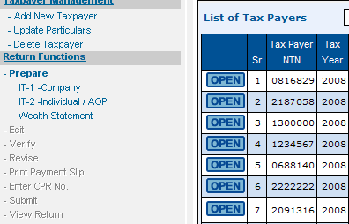
2.3 Sections of Income Tax Return Form:

    - Registration Section
This section contains the information about the Registration of Taxpayer. When you open the return, this information is automatically filled by the system. If you want to change the information regarding Registration, click the link “Click Here to update”.
Following are the fields that are editable in this section:
- Employer NTN/Name
- Representative NTN/Name
- Year Ending
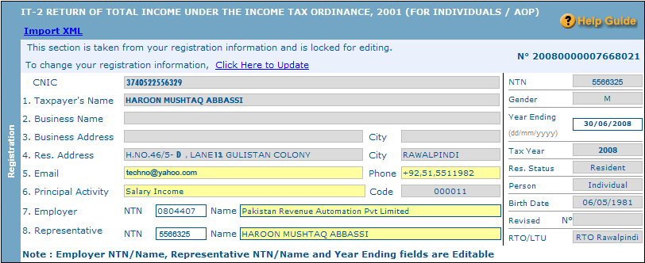

    - Share Holding/Ownership Section
This section is also locked on Income Tax Returns Form. If you have declared your Share Holders/Owners in the Registration -> Enrollment -> Profile Management (Directors/ Shareholders Section), those will be shown here. This section is mandatory for the following types of Taxpayers:

Corporate (Company)
AOP (Association of Persons)
If you are of any one of the above Taxpayer types, you will be required to provide your Share Holders / Owners details in order to submit your returns.
Click the link “Click Here to update” in the Registration section of the return to go to your Profile Management and add the Share Holders / Owners details under the section Directors/ Shareholders there.(Move to step 2.2 after updating your profile)
Note: In case of Non-Resident Company, please specify at least one Non-Resident Shareholder with the capital invested locally.

2.3.3 Other Sections of the Return
Fill the rest of the Return (Only the fields that apply to you).
2.3.3.1 Annexures
There are 3 annexures in the return form:
Annexure A (Link : Annex A Tax Ammortization / Tax Depreciation)
Annexure B (Link : Annex B Brought Forward Loss Adjusted/ Loss for the year Carry Forward)
Annexure C (Link : Annex C Tax Already Paid)
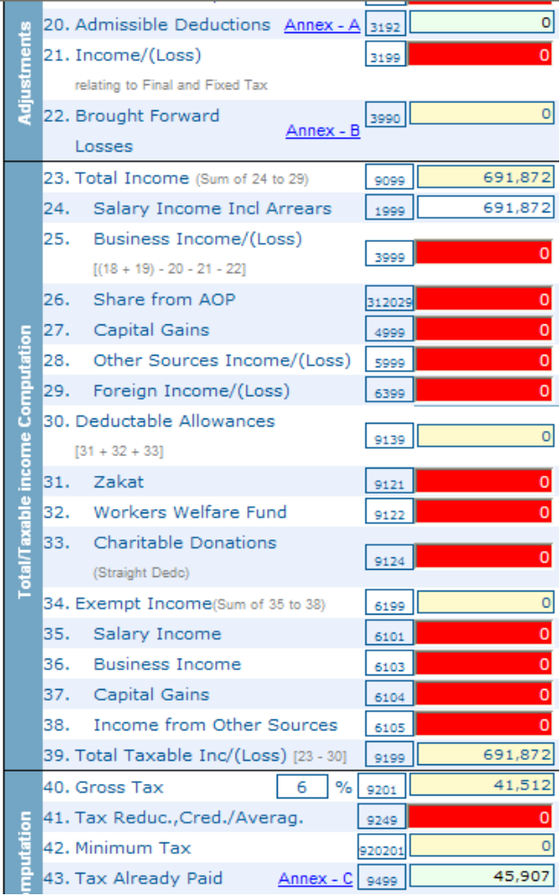

Note :
- Please make sure that the Pop-Up Blocker in Internet Explorer is disabled before clicking the links of Annexures.
- The Rate of Gross Tax is auto-calculated according to your details/declarations.
- All the fields in Yellow color are auto-calculated by the system.
- In case of Annexure B, no amount is brought back to the main return form, from the annexure.
Clicking an Annexure Links opens a help screen to calculate the values. Popup Blocker should be disabled in order to view this screen. Enter the values in the fields that apply to you and when you are done, click the “Save” button on the annexure.
      - Audited Accounts Section (ONLY for IT-1 (Company))
The Corporate Taxpayers are required to attach copy of Audited Accounts/Balance Sheet/income Statement details as required under subsection 2(A) of section 114 of the Income Tax Ordinance, 2001 and under clause 2 of the 2nd schedule of the Income Tax Rules 2002. In order to attach, click the “Attach/Remove” link

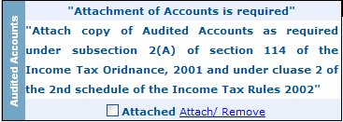

On clicking the link, the following window will open:

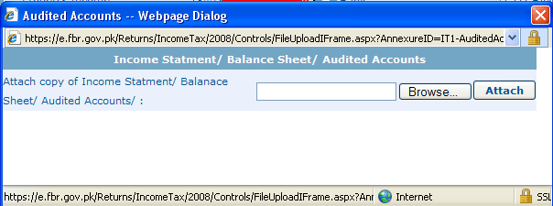

Click the “Browse” button to select the file. The file can be only of the following types:
- PDF
- Microsoft Word Document
- Microsoft Excel Workbook
After selecting the file to attach, click the “Attach” button. And the file will be attached in a while (depending on the size of the file). As soon as the file is attached, a “Tick” mark is visible against the “Attached” word on the Main Return Form.

To remove an attached file, click the “Attach/Remove” link and in the pop-up window, click the “Remove” button.
NOTE:
- If you have multiple files, merge them into a single PDF, Word Document or Place them into different worksheets of a workbook and then attach the workbook.
- Make sure that the size of the file is not more than 4MB. Remove additional images, details to reduce the size of the file.

      - Payment/Refund Section.
- The last section Payment/Refund contains bank information fields. Bank fields are only for those who have Net Tax Refundable. (This feature has been added for future)
- If Bank Branch is not available. Don’t fill data in these fields.
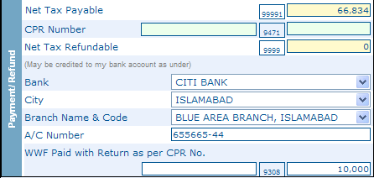
- Buttons in the form.

3.1) Save.
- Fill and Save the IT Returns Form, to prepare your Return. Click “Save” button to do so.
- Save will only be available before verification. Once the return is verified / submitted, the save button will be disabled.
  - Verify & Unverify.
- When you have “Saved/Prepared” your Return, verify it by clicking the “Verify” button.
- You have to save the return once, in order to verify it.
- After verification, the Return can either be Submitted or Unverified by clicking “Unverify” button.
- You cannot edit/update the return in Verified mode.
  - E-Payment & Enter CPR No.
- If there is some amount in the “Net Tax Payable” field (Code: 99991), you will need to pay this amount before submitting your return.
- There are two ways to make the payment against the return.
- e-Payment: If there is some Net Tax Payable against your return, the button “e-Payment” will be enabled. Click the button and follow the instructions to create an e-Payment. A PSID (Payment Slip ID) is generated by the system. Take the Payment Slip (Print) to the bank and make payment against it. A CPR Number will be issued by the bank, against the payment. Until the payment is cleared by the Bank, all the buttons remain disabled except the Print Return button. Once the payment is cleared by the bank, the button “Enter CPR No.” is enabled

- Manual Payment: Pay the Net Tax Payable amount in the bank, against your Income Tax Return. A CPR Number will be issued by the bank, against the payment.
- After you have been issued a CPR Number by the bank, against the payment, enter the CPR No. issued and the amount paid against the CPR, by clicking “Enter CPR No.” button. Now the Submit button will be enabled.
  - Submit.
- Submit button is enabled after you have entered the CPR No.
- You can submit the Return only after you have VERIFIED the return.
- Submit the IT Return by clicking the “Submit” button. You will receive an Acknowledgment Slip. Now the return is locked for any editing. To change anything in the return, you will have to revise it and work on the revised return.
  - Revise
- Revise button is enabled only after you have submitted the Return.
- By clicking the “Revise” button you can revise the Return.
- When you click the Revise button, you have to follow the above mentioned steps to submit the Revised Return.

  - Print Return
- Print Return button is used to print the Income Tax Return.
- After clicking this “Print Return” button the Return you have submitted will be opened in Acrobat Reader.
- You must have Acrobat Reader to get print of the Return.
NOTE : Make sure Pop-ups are enabled in your Internet Explorer, before clicking the Print Return button
  - Acknowledgment
- On clicking the “Acknowledgement” button, a web-based acknowledgement slip is displayed which may be printed by clicking the print button:

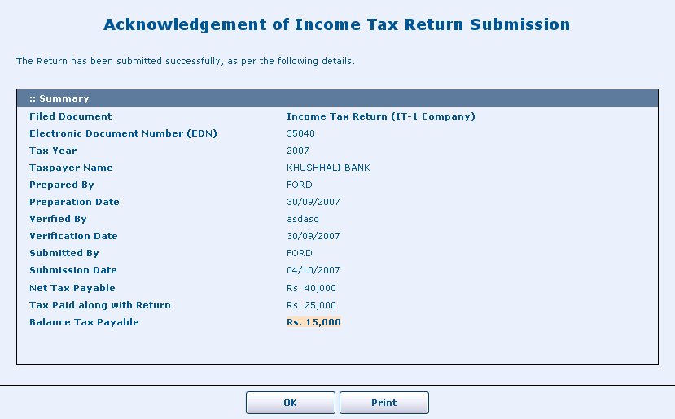

* The Return is filed after you have submitted the Return.
4.0 Important Points to Note.
- Use “Internet Explorer 6 or Above”.
- This site is best viewed at resolution 1024x768.
- Use the “Tab Key” or “Mouse Click” to move between the fields.
(Do not use the "Enter Key").
- Use "Mouse Click" to move to a previous field.
- Read the ToolTips on the different controls(i.e. buttons, labels)
- Due Date for e-Filing of IT-1 is 31st October for companies whose Year Ending date is 31-12-2007.
- Due Date for e-Filing of IT-1 is 31st December for companies whose Year Ending date is 30-06-2008.
- Due Date for e-Filing of IT-2 is 31st October.
- Yellow Textbox Fields are auto calculated fields.
- Green Textbox Fields are retrieved/brought from Other Screens.
- To update your Information (Registration Information i.e. Name, address etc.). Click the Link (Click Here for Update).
- The Fields with abbreviation captions can be viewed completely by bringing the mouse cursor on them.
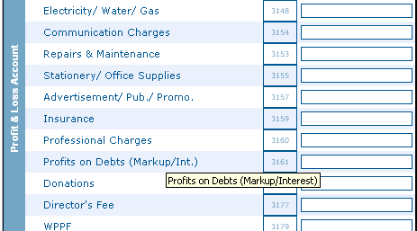

- At any point, the status of the return may be viewed from the bar below at the top of the return:

- If the following message appears on your Internet Explorer, please unblock Pop-up.
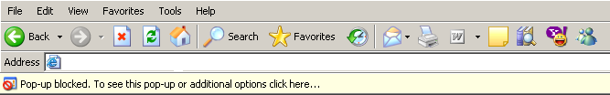

- To unblock the Pop-up right click on the Pop-up bar and click the option “Always allow the Pop-ups from this site”.


